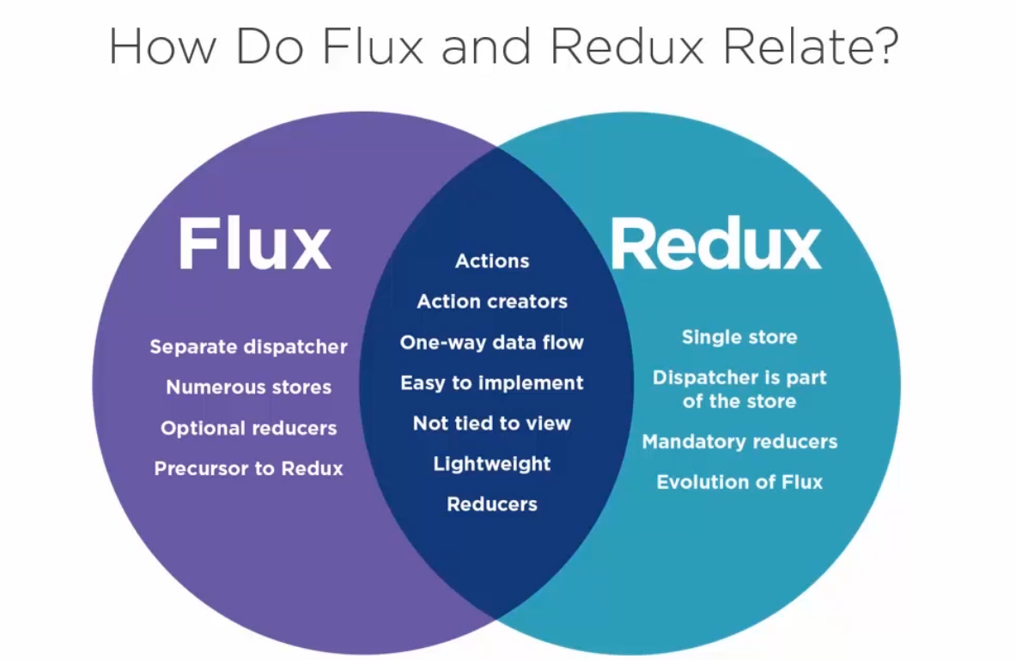

Sequence for reading or understanding.

Flux Basic

**[Flux is an] application architecture for React utilizing a unidirectional flow. -By GitHub**

Unidirectional Data Flow

The Dispatcher

Flux Store

The ReduceStore

Idempotency

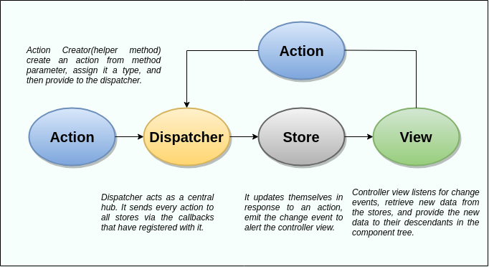

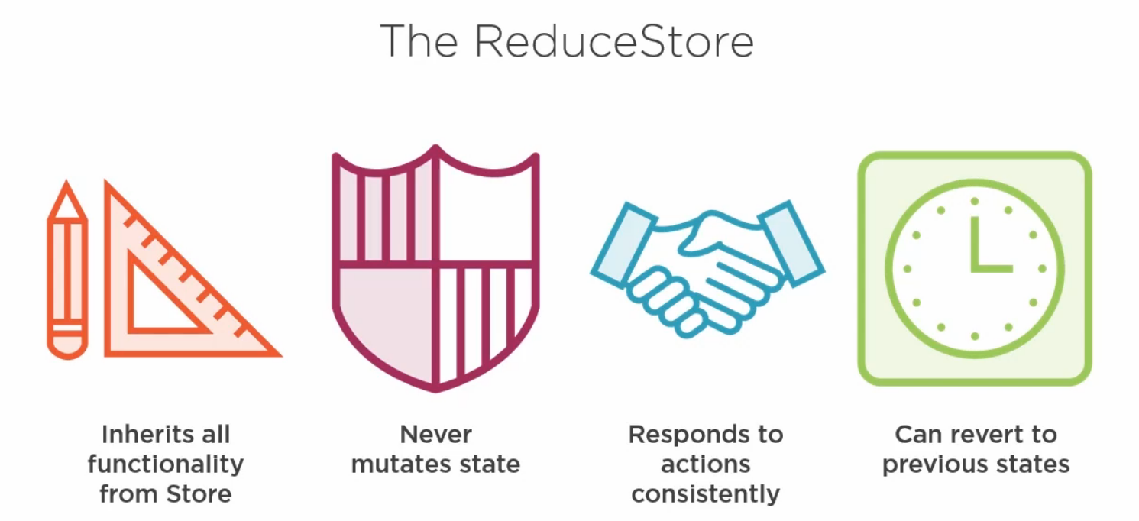

<https://i.redd.it/vezwyo0qq4lz.png>

